Bodies in Motion presents
New
Dates!

Family Nutrition Workshops
  - for moms, dads, and kids!

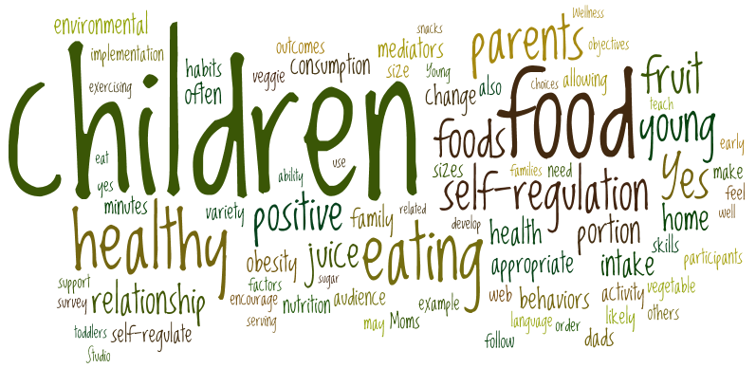
Guide your family in developing a healthy relationship with food through family games, activities for kids, and parent discussion, practice, and support.
Join us for one or both Saturdays!
11:45am-12:45pm
March 31 & April 14
Bodies in Motion Wellness Studio
Jefferson Ave & Valley St, Maplewood
$15 per family, per session ($25 for both)
Space is limited; please email marissa@nutritiontranslation.com
to reserve a place

Do you wonder how to make sure your children grow up with healthy eating habits?

Are you concerned about a picky eater?

Do you wish your children ate more veggies?

Could you use a little help interpreting the vast amount of nutrition information we all encounter each day?

Would you like to talk with other families about growing healthy kids?

Marissa Burgermaster, M.A.Ed., Nutrition Educator, has nearly ten years of experience in elementary and middle school teaching, N-12 curriculum writing, and education program evaluation. She is currently completing an M.S. in Nutrition and Food Science with a concentration in Nutrition Education. She focuses on making the scientific evidence about nutrition accessible for everyone and is available for corporate wellness programs, nutrition workshops, and one-on-one and family coaching.
www.nutritiontranslation.com

